## 



# American International University-Bangladesh

## Dept. of Computer Science and Engineering

Course Name: MICROPROCESSOR AND EMBEDDED SYSTEMS

Section: M Session: Spring 21-22 Group No: 03

Course Instructor: Dr. Ferdous Jahan Shaun

Submission Date: 12-02-2022

# Title: Familiarization with microcontroller, study of blink test using and implementation off a traffic control system using microcontrollers.

**Group Members**

|  |  |
| --- | --- |
| **Name** | **ID** |
| Mohammad Sakib Islam Mazumder | 19-39290-1 |
| Munira Zebin | 19-41014-2 |
| Samir Faisal | 19-41037-2 |
| Nasim Reza Hridoy | 19-41045-2 |
| Shafiul Islam Mazumder | 19-41370-3 |
| Arpita Saha | 19-41363-3 |
| Puravi Debnath Nitu | 19-41371-3 |
| S. M. Rizwanul Hassan | 19-41386-3 |

Contents

Title: Familiarization with microcontroller, study of blink test using and implementation off a traffic control system using microcontrollers. 1

1. Abstract 3

2. Objectives 3

3. Results 3

i) Simulation Environment 3

ii) Simulation Results 6

iii) Discussion 10

4. Question for Report Writing 10

5. Conclusion 10

6. References 10

Figure 1: Proteus 4 Phase-1 3

Figure 2: Proteus 4 Phase-2 3

Figure 3: Proteus 4 Phase-3 4

Figure 4: Proteus 4 Phase-4 4

Figure 5: Proteus 4 Phase-5 4

Figure 6: Proteus 4 Phase-6 4

Figure 7: Proteus 4 Phase-7 5

Figure 8: Proteus 4 Phase-8 5

Figure 9: Tinkercad Phase-1 5

Figure 10: Tinkercad Phase-2 5

Figure 11: Red led on 7

Figure 12: Yellow led on 7

Figure 13: Green led on 7

Figure 14: Complete traffic control system in tinkercad 8

Figure 15: Red led on using tinkercad 8

Figure 16: Yellow led on using tinkercad 9

Figure 17 Green led on using tinkercad 9

# Abstract

In this lab report, we will design a traffic control system via proteus 8 software and Tinkercad web version. Firstly, we will build a circuit which includes 3 LED (RED, Yellow, Green), 3 Terminal and 1 Ground with series connection. In software portion, we have to add a source code where it controls the circuit. After build the code circuit will perform successfully. And the traffic control works properly. Same process follows the Tinkercad.

# Objectives

1. Learning to make the LED blink using Arduino and the delay functions.
2. Implementation of a traffic control system using Arduino.

# Results

## Simulation Environment

## Proteus 4 Software

|  |  |
| --- | --- |
| Figure 1: Proteus 4 Phase-1 | Figure 2: Proteus 4 Phase-2 |

* Figure 1: Open Proteus software. Then Click New Project.
* Figure 2: Write the project name and then click next

|  |  |
| --- | --- |
| Figure 3: Proteus 4 Phase-3 | Figure 4: Proteus 4 Phase-4 |

* Figure 3: Select DEFAULT and then click next
* Figure 4: Select First Option and then click next

|  |  |
| --- | --- |
| Figure 5: Proteus 4 Phase-5 | Figure 6: Proteus 4 Phase-6 |

* Figure 5: Select create Firmware Project and then click next.
* Figure 6: Click Finish

|  |  |
| --- | --- |
| Figure 7: Proteus 4 Phase-7 | Figure 8: Proteus 4 Phase-8 |

* Figure 7: This is the dashboard of Proteus Software.
* Figure 8: This is the Source Code Option where Code has been written.

## Tinkercad Web Version

|  |  |
| --- | --- |
| Figure 9: Tinkercad Phase-1 | Figure 10: Tinkercad Phase-2 |

* Figure 9: This is the dashboard of Tinkercad. Select Circuit Option and then click Create New Circuit.
* Figure 10: This is the homepage of Tinkercad where circuit will build.

## Simulation Results

## Coding part

|  |  |
| --- | --- |
| void setup() {  pinMode(8,OUTPUT);  pinMode(10,OUTPUT);  pinMode(12,OUTPUT);  }  void loop() {  digitalWrite(8,HIGH);  delay(3000);  digitalWrite(10,HIGH);  delay(1000);  digitalWrite(8,LOW);  digitalWrite(10,LOW);  digitalWrite(12,HIGH);  delay(3000);  digitalWrite(12,LOW);  delay(500); | digitalWrite(12,HIGH);  delay(500);  digitalWrite(12,LOW);  delay(500);  digitalWrite(12,HIGH);  delay(500);  digitalWrite(12,LOW);  delay(500);  digitalWrite(12,HIGH);  delay(500);  digitalWrite(12,LOW);  digitalWrite(10,HIGH);  delay(1000);  digitalWrite(10,LOW);  } |

* Code details: In the setup function we declare that red, yellow and green led connect in 8, 10 and 12 no pin of Arduino uno board. digitalWrite method contain two parameter one is 8 which mean red led connect to 8 no pin and another one is HIGH which means red led will turn on. Delay function contain how many times the led lights are glowing. So, delay(3000) means the red led is glowing about 3 sec. digitalWrite(10,HIGH) means yellow led connect to 10 no pin and it turns on. delay(1000) means the led light is glowing for 1 sec. digitalWrite(8,LOW) means red led will turn off. In the second part of the code, digitalWrite(12,HIGH) means green led connect to 12 no pin and it turns on and delay(500) which means the led light is glowing for half sec. In addition, digitalWrite(12,LOW) means green led connect to 12 no pin and it turns off and delay(500) which means the led light is showing dark for half sec. This process will continue for 3 sec. In the last, digitalWrite(10,HIGH) means green led connect to 10 no pin and it turns on and delay(1000) which means the led light is glowing for 1sec. digitalWrite(10,LOW) mean led light will off. digitalWrite(10,HIGH) means green led connect to 10 no pin and it turns on and delay(1000) which means the led light is glowing for 1sec. digitalWrite(10,LOW) mean led light will off.

## Simulation using Proteus 4 Software

|  |  |  |
| --- | --- | --- |
| Snipping Tool  Figure 11: Red led on | Snipping Tool  Figure 12: Yellow led on | |
| Snipping Tool  Figure 13: Green led on | |

* Figure 11: After simulation red led is glowing for 3 sec.
* Figure 12: After 3 sec of glowing red led, yellow led will turn on and glowing for 1 sec simultaneously, then red led will turn off and yellow led will glow extra 2 sec and it’s also off.
* Figure 13: Then green led will glow for 1 sec and blink 3 times at 1 sec intervals. Then again yellow led will glow and this process running continuously.

## Simulation using Tinkercad web version

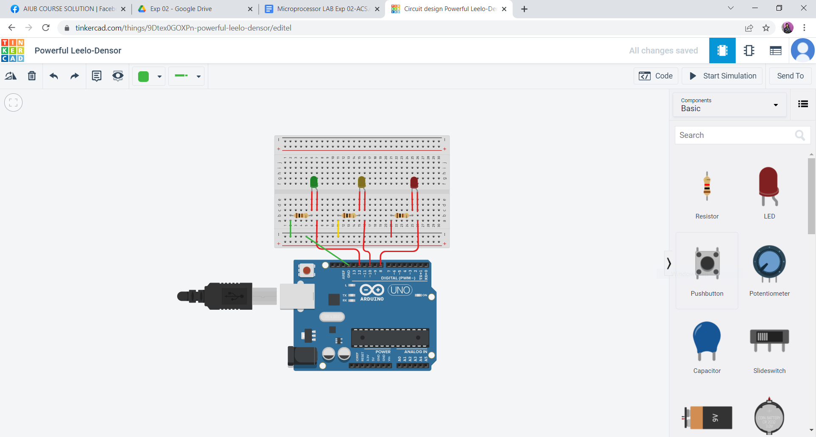

Figure 14: Complete traffic control system in tinkercad

* Figure 14: At first, we take small a breadboard, in this breadboard we put 3 resistors (100 ohm). Then we connect red led, yellow led and green led gradually to the resistors and Arduino uno board’s 8, 10 and 12 no pin. Then in the coding section we implement the traffic control system code.

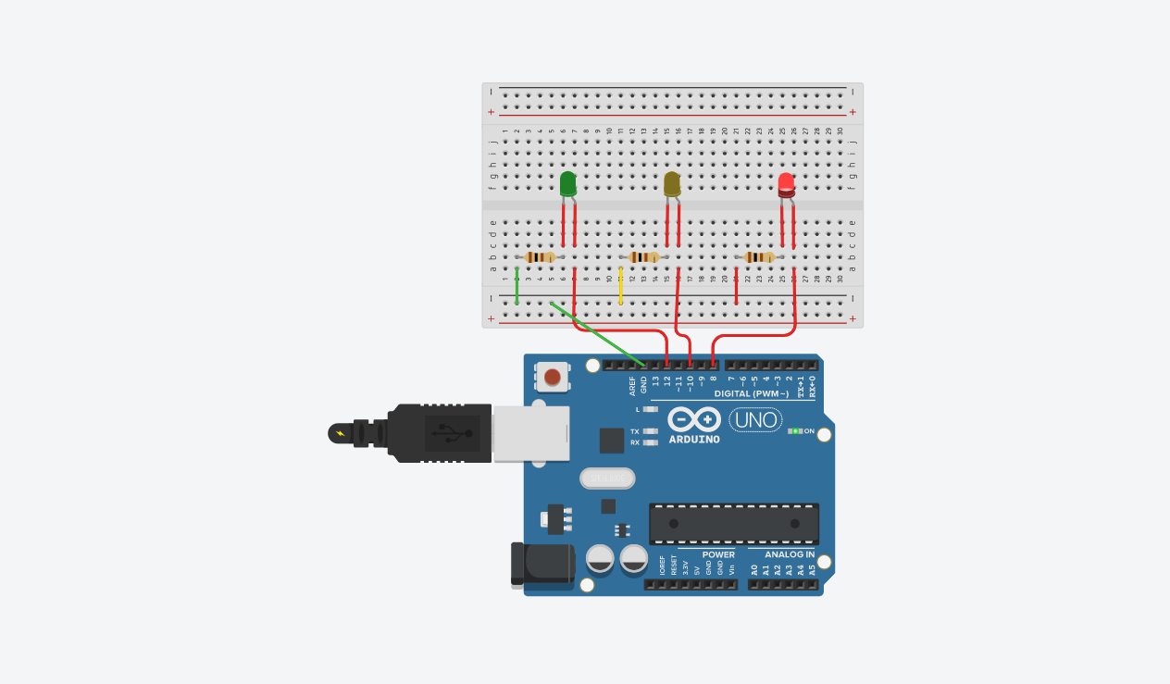

Figure 15: Red led on using tinkercad

* Figure 15: After implementation the code, we simulate the circuit. In result red led is glowing for 3 sec.

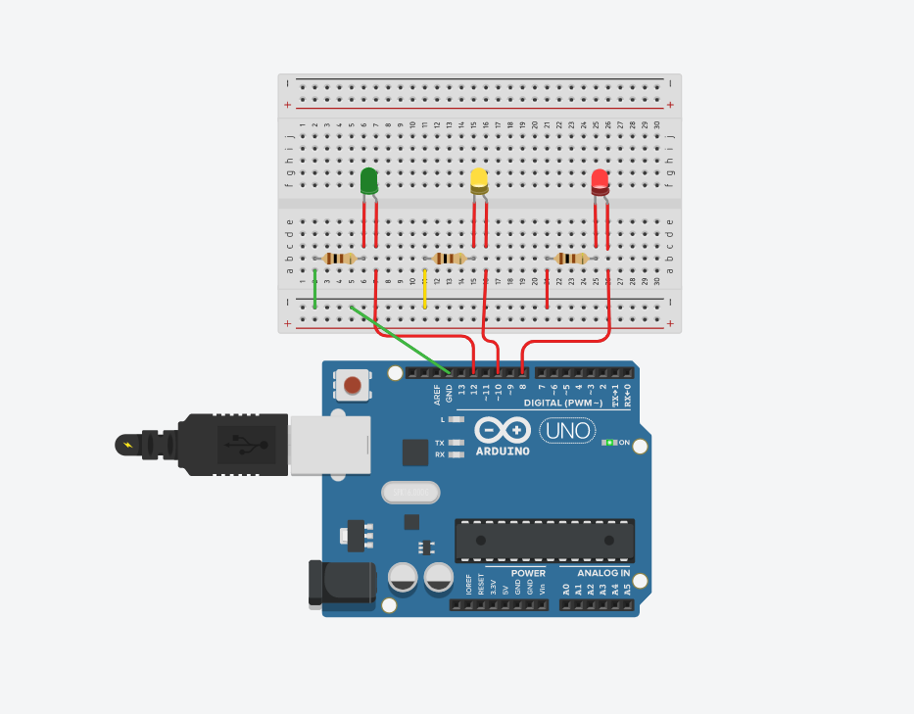

Figure 16: Yellow led on using tinkercad

* Figure 16: Then red led and yellow led will glow simultaneously for 1 sec. After thar red led will stop and yellow led will glow for extra 2 sec. Then green led will also stop.

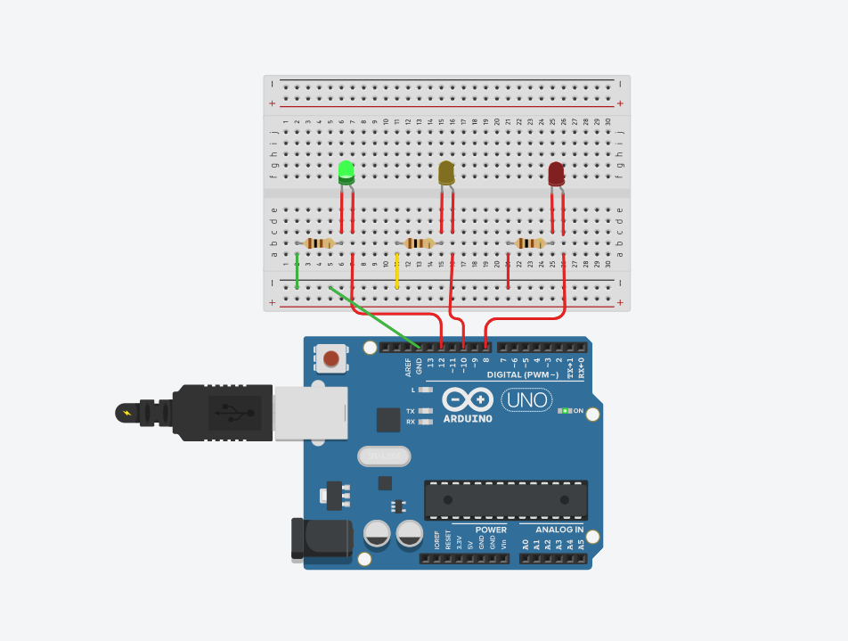

Figure 17 Green led on using tinkercad

* Figure 17: After that the green led will glow for 1 sec and blink 3 times at 1 sec intervals. Then again yellow led will glow and this process running continuously.

## Discussion

In previous sector we discuss about the simulation environment. Basically, traffic control system has been adaptable in three ways. Now we talk about all three ways. First if we talk about the first path. On this path section there are three LED’s which is connected with Arduino also this three LEDs are used with ground. In second path we using Tinkercad for implement the approach. We used a breadboard and LED’s and some resistors and all are connected to the breadboard. We used this connection for implement the system. Finally In last path the system implemented with Arduino IDE and we used the same system for generated id also hex file generated by it. Again, we used proteus Software for implemented the process Finally for the traffic control system all the point of view has implemented the system properly.

# Question for Report Writing

All codes and scripts included. All codes and scripts have been implemented by proteus and we discuss in the result section.

# Conclusion

In this simulation, the goal was to build a traffic system. Two different software packages along with three different approaches were used to do the simulation. Open source of the microcontroller board like Arduino Uno and the source code were implemented to build the system. Priority was given to having no errors or difficulties in understanding. Everything is done perfectly.

# References

1. https://www.coursera.org/learn/arduino/lecture/ei4ni/1-10-first-glance-at-a-program
2. <https://www.arduino.cc/>.
3. Jeremy Blue; Exploring Arduino: Tools and Techniques for Engineering Wizardry